Using Comware 5500 in iMC discovered using SNMPv3.

**Labels: HPE Comware Switch**

**Problem:**

Comware Switch model- HP A5500-24G-4SFP HI Switch with 2 interface Slots (JG311A), was added under Resource -> Add Device tab in IMC.

On switch, write permission was enabled.

SNMPv3 test credentials test always failed from IMC

**Diagnostics:**

Tried to correct SNMPv3 settings template under System->Resource Management->Access Resource Template. This did not help.

Making appropriate settings under below SNMPv3 batch operation for IMC also did not help.

Resource --> BAtch operation-->Device configuration > Device Configuration guide > Select Operation -> "Config SNMPv3 Param(Comware)"

[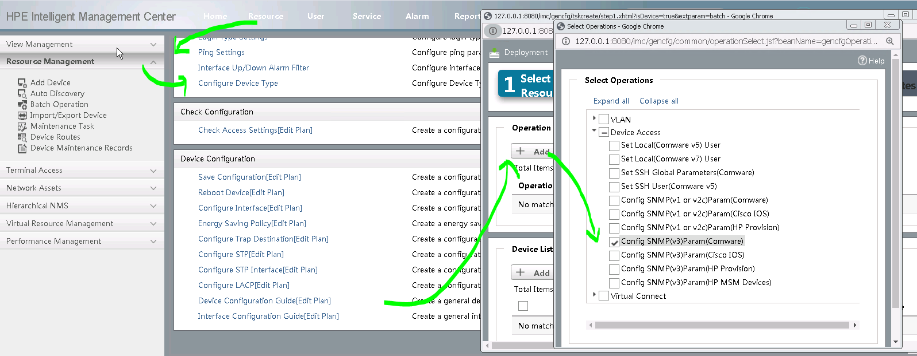](https://akb.arubanetworks.com/media/ckuploads/1110/2022/06/30/tried-batch-snmpv3-config.PNG)

**Solution:**

**Solution:**

With correct template or batch operation.

Below shown write-view was required to be configured in switch to make it work with IMC.

[5500]*snmp-agent group v3 group1 privacy****write-view ViewDefault***

Please note: ViewDefault is the default ISO MIBview, evident from following command:

<5500-tcl>display snmp-agent mib-view  
   View name: ViewDefault  
       MIB Subtree: iso  
       Subtree mask:  
       Storage-type: nonVolatile  
       View Type: included  
       View status: active

   View name: ViewDefault  
       MIB Subtree: snmpUsmMIB  
       Subtree mask:  
       Storage-type: nonVolatile  
       View Type: excluded  
       View status: active

   View name: ViewDefault  
       MIB Subtree: snmpVacmMIB  
       Subtree mask:  
       Storage-type: nonVolatile  
       View Type: excluded  
       View status: active

   View name: ViewDefault  
       MIB Subtree: snmpModules.18  
       Subtree mask:  
       Storage-type: nonVolatile  
       View Type: excluded  
       View status: active

   View name: ViewDefault  
       MIB Subtree: hh3cLI  
       Subtree mask:  
       Storage-type: nonVolatile  
       View Type: excluded  
       View status: active

<5500-tcl>display snmp-agent mib-view

Here is an example, where it shows that Writeview: ViewDefault was not specified for the SNMPv3 group in use, which created this issue.

[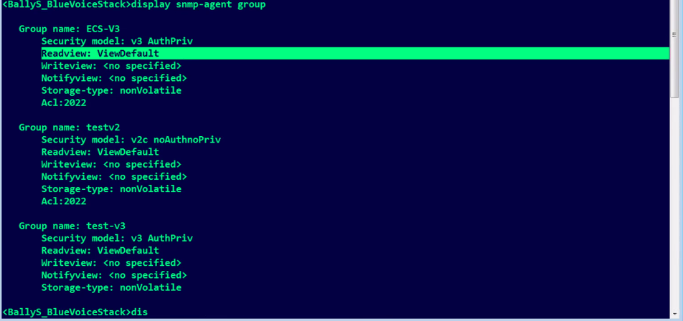](https://akb.arubanetworks.com/media/ckuploads/1110/2022/06/30/view-settings.PNG)

Tags: HPE Comware Switch, 10.01.0040, #snmpv3, snmpv3 group, write-view